
291 Brant Road
Lincoln LN5 9AB

Tel: 01522 724 411
42 St Catherines
Lincoln LN5 8LZ

Tel: 01522 724 411

July 2024

To: Patient

Please share this information with other members of your household who are registered with Brant Road and Springcliffe GP Surgery

Dear Patient,

RE: Closure of the Springcliffe Branch Site located at 42 St Catherines, Lincoln, LN5 8LZ.

We are writing to inform you that following our recent consultation and engagement exercise with patients, staff, and other stakeholders, we have made the difficult decision to close the Springcliffe Branch site. This proposal has been accepted by the Lincolnshire Integrated Care Board (ICB) and the site will close on 31st October 2024.

This decision was not made lightly and followed a comprehensive review process. Our primary goal has always been to provide the highest quality care to our patients.

We would like to thank all of our patients who took the time to respond to our request for feedback, and to those who took the time to attend our patient engagement events. Your input into the process has been invaluable to us and will help us to shape our services moving forward.

The closure of the branch will not affect your registration with Brant Road Surgery and staff very much hope that you will remain as a patient. The address, contact details and opening hours of the Brant Road site are included on the practice website at: brantroadsurgery.co.uk.

For patients who struggle to use online services for ordering prescriptions and cannot feasibly make their way to the surgery to drop off their prescription requests please contact us so that we can plan how to manage your prescriptions.

If you wish to register with a different practice you are free to do so. Further details of the process is given in the Frequently Asked Questions document which will also answer some of the other questions you may have about the branch closure. The Frequently Asked Questions document is available on our website and paper copies are also available from the practice.

We understand that this news may bring about questions and concerns. We are here to support you throughout this process and are available to address any queries you may have. If you have any questions you can contact the practice using the details which can be found at the top of this letter.

Yours sincerely,

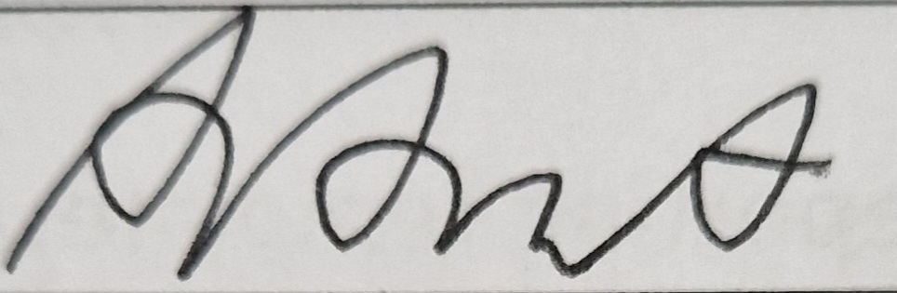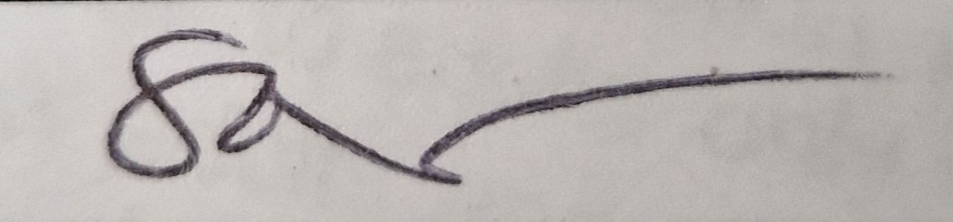

Dr Abigail Hurst Dr Sadie Aubrey
Senior Partner Partner

* Integrated Care Board - the statutory organisation responsible for bringing the NHS together locally to improve population health and establish shared strategic priorities within the NHS

If you would like to request information in alternative formats, please contact the Patient Advice and Liaison Service (PALS) by telephone on 0300 123 9553 or by email at LHNT.LincsPALS@nhs.net. The service is open 9am – 5pm Monday to Friday (except Bank Holidays).

